A TECHNICAL REPORT ON STUDENTS INDUSTRIAL WORK EXPERIENCE SCHEME (SIWES)

HELD AT
ODFeL FEDERAL POLYTECHNIC,
MUBI, ADAMAWA STATE

FROM: OCTOBER, 2023
TO: JANUARY, 2024

BY
ISMAIL YAUBA
(ST/CS/ND/22/309)

A SIWES REPORT SUBMITED TO THE DEPARTMENT OF COMPUTER SCIENCE, SCHOOL OF SCIENCE AND TECHNOLOGY FEDERAL POLYTECHNIC, MUBI, ADAMAWA STATE, NIGERIA
IN PARTIAL FUFILMENT OF THE REQUIREMENTS FOR THE AWARD OF NATIONAL DIPLOMA (ND) IN COMPUTER SCIENCE

MARCH, 2024

ATTESTATION
I Ismail Yauba hereby attest that I did my Industrial Attachment Program at ODFeL Federal Polytechnic, Mubi, Adamawa State between October, 2023, to January, 2024, and this report is prepared by me and submitted to the SIWES coordinator as required. I understand that all the information contained in this report are correct and will be penalized if found to be false. I also know that the SIWES coordinator may request for additional evidence as requested for reconciliation.

………………………………………… .……………………….
ISMAIL YAUBA DATE
(ST/CS/ND/22/309)

CERTIFICATION
This is to certify that Ismail Yauba with a registration number ST/CS/ND/22/309 undergoes his industrial training SIWES at ODFeL Federal Polytechnic, Mubi, Adamawa State. In partial fulfillment of the requirements for the award of National Diploma (ND) in computer science, Federal Polytechnic, Mubi, as certified by the undersign officer.

Mr. Hyellamada Simon …………………………
DEPARTMENTAL SIWES CO-ORDINATOR DATE

DEDICATION
I dedicate this technical report to my lovely parents who gave me all the support and care throughout my SIWES program.

ACKNOWLEDGMENTS
I thank God Almighty for making me to undergo students industrial work experience scheme (SIWES) successfully.
My gratitude goes to my parent for their prayers, financial and moral support during my attachment.
I also appreciate the kind gesture of my brothers and sisters and those who supports me in prayers and contribution during my industrial attachment.
I whole heartedly thank my Head of department Mallam Kassim Mustapha, SIWES coordinator Mr. Hyellamada Simon and all lectures of Computer Science for their effort to ensure my success as their students.
I am greatly indebted to my co-SIWES students to mention, may God strengthen our relationship together and grant us academic excellence.
I sincerely thank you all for your contribution and support.

TABLE OF CONTENTS
Title Page - - - - - - - - - i
Attestation - - - - - - - - - ii
Certification - - - - - - - - - iii
Dedication - - - - - - - - - iv
Acknowledgements - - - - - - - - v
Table of contents - - - - - - - - vi

CHAPTER ONE: INTRODUCTION
1.1 Brief History of SIWES - - - - - - 1
1.2 Aims and Objectives of SIWES - - - - - 2
1.3 Roles of student - - - - - - - 2
1.4 Objectives of the report - - - - - - 2

CHAPTER TWO: HISTORY OF THE ORGANIZATION
2.1 Organizational chart - - - - - - - 3
2.2 Brief history of the organization - - - - - - 3

CHAPTER THREE: WORK EXPERIENCE I
3.1 Introduction to computer - - - - - - - 4
3.2 Introduction to Microsoft Word - - - - - - 7

CHAPTER FOUR: WORK EXPERIENCE II
4.1 Introduction to Visual Basic- - - - - - - 10

CHAPTER FIVE: SUMMARY, CONCLUSION AND RECOMMENDATIONS
5.1 Summary - - - - - - - - - 14
5.2 Conclusion - - - - - - - - - 14
5.3 Recommendations - - - - - - - - 14
Reference - - - - - - - - - 15

CHAPTER ONE: INTRODUCTION
1.1 BRIEF HISTORY OF SIWES
SIWES was founded in 1973 by ITF (Industrial Training Funds) to address the problem of tertiary institution graduates' lack of appropriate skills for employment in Nigerian industries. The Students' Industrial Work Experience Scheme (SIWES) was founded to be a skill training programme to help expose and prepare students of universities, Polytechnics and colleges of education for the industrial work situation to be met after graduation.
This system facilitates the transfer from the classroom to the workplace and aids in the application of knowledge. The program allows students to become acquainted with and exposed to the experience required in handling and operating equipment and machinery that are typically not available at their schools.
Prior to the establishment of this scheme, there was a rising concern and trend among industrialists that graduates from higher education institutions lacked appropriate practical experience for employment. Students who entered Nigerian universities to study science and technology were not previously trained in the practical aspects of their chosen fields. As a result of their lack of work experience, they had difficulty finding work.
As a result, employers believed that theoretical education in higher education was unresponsive to the needs of labor employers. Thousands of Nigerians faced this difficulty till 1973. The fund's main motivation for establishing and designing the scheme in 1973/74 was launched against this context.
The ITF (Industrial Training Fund) organization decided to aid all interested Nigerian students and created the SIWES program. The federal government officially approved and presented it in 1974. During its early years, the scheme was entirely supported by the ITF, but as the financial commitment became too much for the fund, it withdrew in 1978. The National Universities Commission (NUC) and the National Board for Technical Education (NBTE) were given control of the scheme by the federal government in 1979. The federal government handed over supervision and implementation of the scheme to ITF in November 1984. It was taken over by the Industrial Training Fund (ITF) in July 1985, with the federal government bearing entire responsibility for funding.

1.2 AIMS AND OBJECTIVES OF SIWES
The Industrial Training Fund’s Policy Document No. 1 of 1973 which established SIWES outlined the objectives of the scheme as:
- Provide an avenue for students in Institutions of higher learning to acquire industrial skills and experience in their respective courses of study.
- Prepare students for the Industrial Work situation they are likely to experience after graduation.
- Expose students to work methods and techniques of handling equipment and machinery that may not be available in their Institutions.
- Make the transition from school to the world of work easier; and enhance students’ networks for later job placements.
- Provide students with an opportunity to apply their knowledge to real work situations, thereby bridging the gap between theory and practice; and vi. Enlist and strengthen Employers’ involvement in the entire educational process; thereby preparing the students for employment in Industry and Commerce.

1.3 ROLES OF STUDENT
- Attend SIWES orientation programme before going on attachment.
- Comply with the establishment’s rule and regulation.
- Arrange living accommodation during the period of attachment.
- Record all training activity done and other assignment in the log book.
- Complete SPEI from ITF, FORM 8 and get it endorsed by the employer for submission to the ITF.

1.4 OBJECTIVES OF THE REPORT
The objectives of the SIWES report are;
- To make thorough explanation of the work done during my four-month industrial training.
- To fulfill the requirement for national diploma in computer science.
- To contribute to the body of knowledge and to enhance the understanding of the writer about a similar or same job.

CHAPTER TWO: HISTORY OF THE ORGANIZATION
2.1 ORGANIZATIONAL CHART
Director

CENTRAL PROGRAMME COORDIANTOR

DEPUTY COORDINATOR
HEAD OF COMPUTER LAB
EXAM OFFICE

Figure 2.1: Organizational Chart

2.2 BRIEF HISTORY OF ODFeL FEDERAL POLYTECHNIC, MUBI
The ODFeL unit it was established in 2023 in Federal Polytechnic Mubi, they are round a programme of both HND and ND in computer science, Public Administration and Management, Business Administration and management, mass communication department. It is a director unit which the programme should be online where a student can attend a lecture online, test, assignment online, a student can attend his lecture at his own flexible time

CHAPTER THREE: WORK EXPERIENCE I

3.1 INTRODUCTION TO COMPUTER SYSTEM
3.1.1 Monitors
Monitors are vital display devices used in various aspects of modern life. They provide visual feedback for computers, gaming, entertainment, and communication needs. Monitors come in diverse types and technologies to suit different preferences.
Uses of monitors
- Computing: Display output for computers and laptops.
- Entertainment: Viewing multimedia content like movies and videos.
- Gaming: Offering immersive gaming experiences.
- Communication: Facilitating video conferencing and online meetings.
Types of monitors
- LCD: Utilizes liquid crystal technology for energy-efficient display.
- LED: Illuminates display using light-emitting diodes for vibrant visuals.
- Curved: Provides an immersive viewing experience with a gently curved screen.
- Ultra-Wide: Offers expanded horizontal screen space for multitasking.
- Touchscreen: Allows interaction via touch-sensitive panels.
- Gaming: Optimized for gaming with high refresh rates and low response times.
3.1.2 Keyboard
Keyboards are essential input devices used for entering text, commands, and data into computers and electronic devices. They come in various types, including membrane, mechanical, ergonomic, wireless, gaming, and virtual keyboards, catering to different needs and preferences.
Uses of Keyboard
- Text Input: Primary for typing emails, documents, chatting, and internet searches.
- Command Input: Entering commands and shortcuts for software control and efficient navigation.
- Gaming: Specially designed for gamers with customizable features and optimized performance.
- Accessibility: Providing options for users with disabilities or special needs.
- Data Entry: Widely used in industries such as retail, healthcare, finance, and logistics.
- Function Keys (F1-F12):
Function keys, located at the top row of a keyboard, provide quick access to specific functions or commands within software applications and operating systems.
Examples:
- F1: Accessing context-sensitive help.
- F2: Renaming files or folders quickly.
- F3: Initiating searches within applications.
- F4: Opening or closing windows and menus.
- F5: Refreshing or reloading content.
- F6: Moving cursor within interfaces.
- F7: Initiating spell check.
- F8: Accessing boot menu during startup.
- F9: Refreshing display.
- F10: Accessing menus in software applications.
- F11: Toggling full-screen mode.
- F12: Opening developer tools or debugging consoles.
Various Parts of a Keyboard:
- Keys: Individual buttons for inputting characters, commands, and functions.
- Alphanumeric Keys: Letters (A-Z) and digits (0-9).
- Function Keys: Provide quick access to specific functions.
- Numeric Keypad: Located on the right side, for numerical input and arithmetic operations.
- Navigation Keys: Move cursor or selection within documents and interfaces.
- Enter Key: Confirms commands and creates new lines.
- Backspace and Delete Keys: Delete characters left or right of the cursor.
- Escape Key: Cancels or exits operations.
- Function Lock (Fn) Key: Activates secondary functions.
- Windows (Command) Key: Accesses system shortcuts on Windows keyboards.
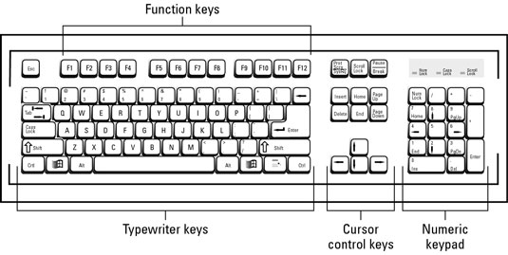
Figure 3.1: Diagram of a Keyboard

3.1.3 Introduction to Mouse
The mouse is a crucial input device that allows users to control the movement of a cursor on a computer screen. By clicking and dragging, users can interact with graphical interfaces, navigate menus, and execute commands efficiently.
Uses of Mouse
- Pointing and clicking for interface navigation.
- Dragging and dropping for file organization.
- Scrolling through documents and web pages.
- Gaming with precision and speed.
- Graphic design and CAD applications.
- Accessibility for users with disabilities.
Types of Mouse
- Optical Mouse: Uses LED or laser technology for precise tracking.
- Wireless Mouse: Connects via RF or Bluetooth for mobility.
- Gaming Mouse: Optimized for gaming performance with customizable features.
- Trackball Mouse: Utilizes a stationary ball for cursor control.
- Vertical Mouse: Ergonomically designed to reduce wrist strain.
- Touchpad: Built-in pointing device commonly found on laptops.
- Thumb Mouse: Operated primarily with the thumb for comfort and control.


Figure 3.2: Mouse

3.2 INTRODUCTION TO NETWORKING
Networking, also known as computer networking, is the practice of transporting and exchanging data between nodes over a shared medium in an information system. Networking comprises not only the design, construction and use of a network, but also the management, maintenance and operation of the network infrastructure, software and policies.
Computer networking enables devices and endpoints to be connected to each other on a local area network (LAN) or to a larger network, such as the internet or a private wide area network (WAN). This is an essential function for service providers, businesses and consumers worldwide to share resources, use or offer services, and communicate. Networking facilitates everything from telephone calls to text messaging to streaming video to the internet of things (IoT).
3.2.1 Computer Network Types
A computer network is a group of computers linked to each other that enables the computer to communicate with another computer and share their resources, data, and applications. A computer network can be categorized by their size. A computer network is mainly of four types
- LAN (Local Area Network)
- PAN (Personal Area Network)
- MAN (Metropolitan Area Network)
- WAN (Wide Area Network)

LAN (Local Area Network)
- Local Area Network is a group of computers connected to each other in a small area such as building, office.
- LAN is used for connecting two or more personal computers through a communication medium such as twisted pair, coaxial cable, etc.
- It is less costly as it is built with inexpensive hardware such as hubs, network adapters, and Ethernet cables.
- The data is transferred at an extremely faster rate in Local Area Network.
- Local Area Network provides higher security.

PAN (Personal Area Network)
- Personal Area Network is a network arranged within an individual person, typically within a range of 10 meters.
- Personal Area Network is used for connecting the computer devices of personal use is known as Personal Area Network.
- Thomas Zimmerman was the first research scientist to bring the idea of the Personal Area Network.
- Personal Area Network covers an area of 30 feet.
- Personal computer devices that are used to develop the personal area network are the laptop, mobile phones, media player and play stations.
There are two types of Personal Area Network:
Wireless Personal Area Network: Wireless Personal Area Network is developed by simply using wireless technologies such as Wi-Fi, Bluetooth. It is a low range network.
Wired Personal Area Network: Wired Personal Area Network is created by using the USB.

Examples of Personal Area Network:
- Body Area Network: Body Area Network is a network that moves with a person. For example, a mobile network moves with a person. Suppose a person establishes a network connection and then creates a connection with another device to share the information.
- Offline Network: An offline network can be created inside the home, so it is also known as a home network. A home network is designed to integrate the devices such as printers, computer, television but they are not connected to the internet.
- Small Home Office: It is used to connect a variety of devices to the internet and to a corporate network using a VPN

MAN (Metropolitan Area Network)
- A metropolitan area network is a network that covers a larger geographic area by interconnecting a different LAN to form a larger network.
- Government agencies use MAN to connect to the citizens and private industries.
- In MAN, various LANs are connected to each other through a telephone exchange line.
- The most widely used protocols in MAN are RS-232, Frame Relay, ATM, ISDN, OC-3, ADSL, etc.
- It has a higher range than Local Area Network (LAN

Uses of Metropolitan Area Network:
- MAN is used in communication between the banks in a city.
- It can be used in an Airline Reservation.
- It can be used in a college within a city.
- It can also be used for communication in the military.

WAN (Wide Area Network)
- A Wide Area Network is a network that extends over a large geographical area such as states or countries.
- A Wide Area Network is quite bigger network than the LAN.
- A Wide Area Network is not limited to a single location, but it spans over a large geographical area through a telephone line, fiber optic cable or satellite links.
- The internet is one of the biggest WAN in the world.
- A Wide Area Network is widely used in the field of Business, government, and education.
3.2.2 Network devices
Network devices are hardware or software components used to facilitate communication and data transfer between computers and other devices within a network. Some common network devices include:
- Routers: Devices that direct network traffic between different networks. They determine the best path for data packets to travel and facilitate communication between devices on different networks.
- Switches: Devices that connect multiple devices within a local area network (LAN) and manage data traffic by directing packets only to the intended recipient device.
- Hubs: Devices that connect multiple devices within a LAN, but unlike switches, they broadcast data to all connected devices regardless of the intended recipient.
- Firewalls: Security devices that monitor and control incoming and outgoing network traffic based on predetermined security rules, helping to protect the network from unauthorized access and threats.
- Modems: Devices that modulate and demodulate digital data for transmission over analog communication lines, allowing devices to connect to the internet or other networks using telephone lines, cable lines, or wireless connections.
- Access Points (APs): Devices that enable wireless devices to connect to a wired network, typically used to provide Wi-Fi connectivity within a specific area or building.
- Network Interface Cards (NICs): Hardware components installed in computers and other devices to enable them to connect to a network and communicate with other devices.

CHAPTER FOUR: WORK EXPERIENCE II

4.1 INTRODUCTION TO VISUAL BASIC
The Visual Basic 2012 was the programming language that I learnt. It was taught as a platform for developing software programs. Below are some few terms that I learnt.
Program: A program presented to a computer is set of instructions that solve a particular problem.
Programming Language:
Programming Languages refers to the various platforms for writing programs. Each platform has its syntax or rules of operations. Examples of programming Languages include Java, Visual Basic, FORTRAN, Python etc.
Visual Basic is one of the platforms or languages from Visual Studio which contains better tools and language procedure for developing powerful software applications. It is an Object-Oriented Programming Language.

Visual Studio IDE
Microsoft has provided an IDE (Integrated Development Environment) tool called Visual Studio to build applications using programming languages such as C#, F#, Visual Basic, etc., based on our requirements. The Visual Studio IDE will provide a common user interface with various development tools to build applications with different programming languages such as C#, F#, Visual Basic, etc.

HOW TO Create a Project in Visual Studio
After completing a visual studio installation, open visual studio and it will be prompted to sign in for the first time. The sign-in step is optional, so you can skip it, and in the next step, the dialog box will appear and ask you to choose your Development Settings and color theme. Once you select the required options, click on the Start Visual Studio option as shown below.
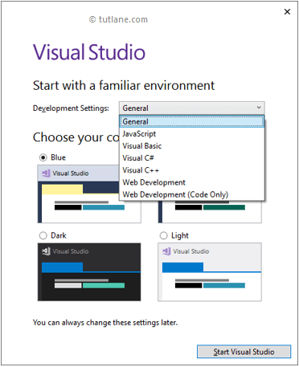
Figure 3.1: Visual Studio IDE start up screen
After the visual studio launch, create a new console application using a visual basic programming language; for that, Go to File à New à select a Project like as shown below.
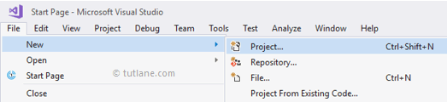
Once you click on Project, a new popup will open in that select Visual Basic from the left pane and choose Console App. In the Name section, give any name for your project and select an appropriate Location path to save your project files, and click OK like as shown below.
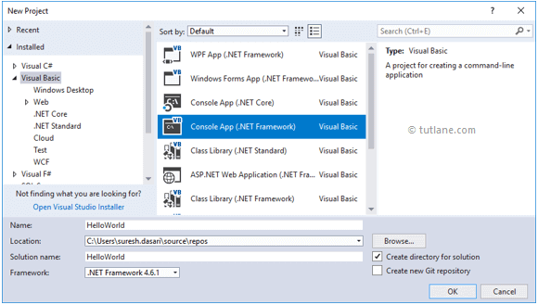
Figure 3.2: Visual Studio New project
Once we click on the OK button, a new console application will be created like as shown below.
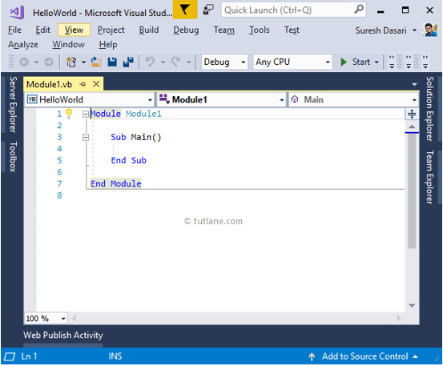
Figure 3.3: Creating new program interface
This is how we can create a console application in a visual basic programming language using a visual studio based on our requirements.
Forms: is the background of your interface of the software you are developing.
Solution Explorer: is where you explore your project Solution
Property Window: is where you change the object properties. Eg, Name, fonts, etc.
Server Explorer: can be used to explorer your database while still working on your VB environment.
VISUAL BASIC TOOLS
There is a difference between a Tool and an Object. A Tool is used to draw an object.
There tools for drawing, and there tools for Language (Language Tools) Instructions
Button: Is used for drawing Buttons which helps in initiating instructions on a program. To do so, a user must click on the button.
TextBox: It is used for adding a TextBox Object which may serve as both an input or output box. It can be used as a page Layout for word processing application.
Label: it is used to draw a Label Object which is used to describe other object. It can also be used as a platform to display some output.
ComboBox: it is used to draw a ComboBox Object which has a pull down list that displays list items. You can add the list in the items property or add them through codes.
RadioButton: the Radio Button Tool is used to draw list of option buttons. It is commonly used in multiple-choice programs such as CBT systems or quizzes.
MenuStrip: the MenuStrip tool is used to add a menu bar to an existing form. The menu bar items can further be added and edited automatically.
ProgressBar: the progressbar is used to indicate the process of an actionespecially when there is a time frame given to it.
VISUAL BASIC VARIABLES
In Visual Basic, Variables will represent storage locations, and each variable will have a particular data type to determine the type of values the variable can hold. Visual Basic is a Strongly Typed programming language. Before we perform any operation on variables, it’s mandatory to define the variable with a required data type to indicate the type of data the variable can hold in our application.

Syntax of Visual Basic Variables Declaration
Dim [Variable Name] As [Data Type]
Dim [Variable Name] As [Data Type] = [Value]
If you observe the above variable declarations, we added a required data type after the variable name to tell the compiler about the type of data the variable can hold.
Item | Description
Dim | It is useful to declare and allocate the storage space for one or more variables.
[Variable Name] | It’s the variable's name to hold the values in our application.
As | The As clause in the declaration statement allows you to define the data type.
[Data Type] | t’s a type of data the variable can hold, such as integer, string, decimal, etc.
[Value] | Assigning a required value to the variable.

CHAPTER FIVE: SUMMARY, CONCLUSION AND RECOMMENDATIONS

5.1 SUMMARY
Student Industrial Work Experience Scheme (SIWES) was established by ITF in 1973 to solve the problem of lack of adequate practical skills preparatory for employment in industries by Nigerian graduates of tertiary institutions. The Scheme exposes students to industry-based skills necessary for a smooth transition from the classroom to the world of work. It affords students of tertiary institutions the opportunity of being familiarized and exposed to the needed experience in handling machinery and equipment which are usually not available in the educational institutions.

5.2 CONCLUSION
I would conclude that the Student Industrial Work Experience (SIWES) has been of great benefit to me for it enables me acquiring more experience. I have successfully finished my attachment. I was able to put the theory acquired (in school) into practical during the four (4) months attachment.
Finally, I want to use this opportunity to thank the federal government of Nigeria for organizing the student industrial Work Experience Scheme (SIWES) program for the benefit of the Nigeria science students.

5.3 RECOMMENDATIONS
As a student who has undergone the SIWES program, the following recommendation is made:
- The school should make SIWES programmed available to all department in the institution to give every student the opportunity to acquire practical knowledge of his idea of study.
- The school should ensure that student on the SIWES is attached to organization or division relevant to their course of student.
- The government should pay more attention or priority on the SIWES programmed because through such programmed students experience what they have learnt in the labour market.
- I equally suggest that schools should ensure that supervisors sent to supervise student on SIWES programmed get to every nook and cranny of the country, this is to enable them know actually if student are really partaking in the programmed.

REFERENCES
Edward, B. M.D (2003). The Effect of SIWES on a student, Federal Ministry of Works, Lagos. Nigeria.
John, Doe (2008). Introduction to web development: responsive designs, McGraw Print New York.

